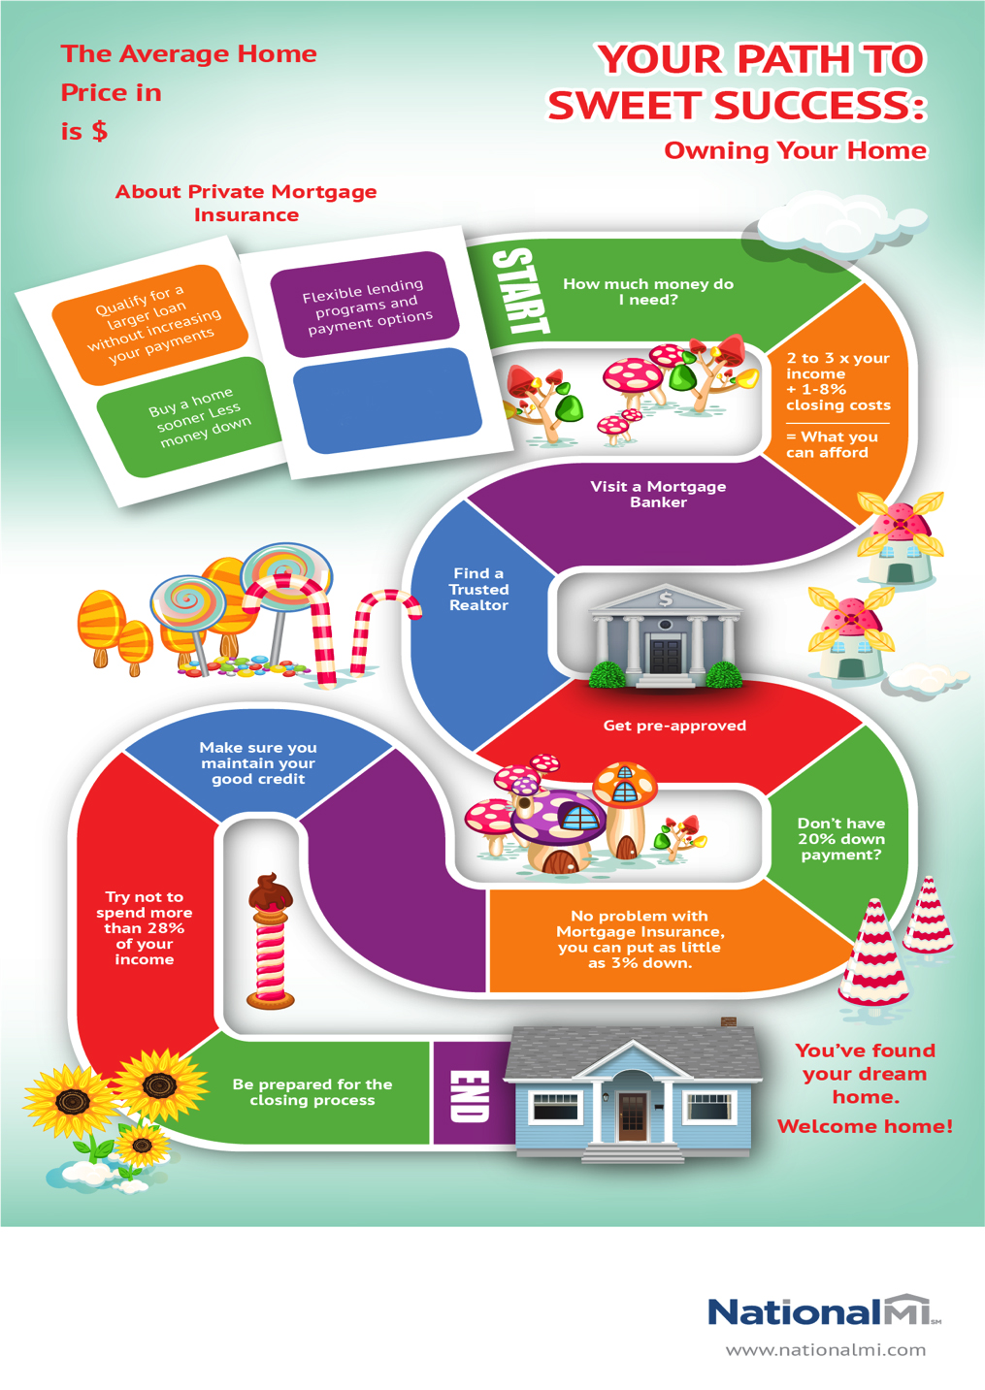

**(00.00)**

**(County)**

Borrower paid MI   
is Cancellable

**Call your realtor**